**METU NCC Fall 2021**

**SFLGHO 2 (Passives)**

**ELEMENTARY GROUP**

**(Student’s Copy)**

**TASK 1. Read the article and answer the following questions. Give LONG answers.**

**THE OSCARS**

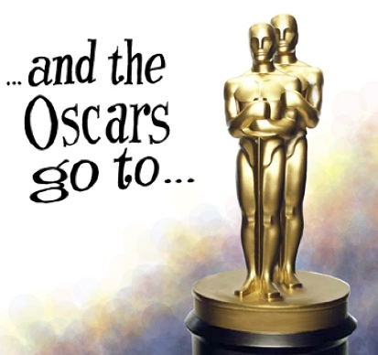The Academy Awards are given out every year to recognize the outstanding work of movie actors, directors and others in the movie-making industry. These awards are called the Oscars, and they are presented in Hollywood in a formal ceremony in spring. Several people are nominated in specific categories, such as Best Movie, Best Actor, Best Music and Best Costumes. One person from each category is chosen by a committee to receive an award. The winner’s name is placed in an envelope, and the envelope is not opened until the night of the ceremony. In the weeks before the ceremony, movie reviewers make predictions about the winners, but the names are not known ahead of time.

When the winner’s name is announced, he or she comes to the stage to receive the award and gives a short speech. The ceremony is very long. In fact, in 1997 the ceremony lasted longer than the movie that won the most awards: Titanic.

When the awards ceremony first started in 1927, 15 awards were presented and the ceremony was attended by only 250 people. Anyone with a ticket could attend the ceremony. Today, about two dozen Oscars are presented. Tickets are not sold to the general public. Invitations are only sent to people in the movie industry and to their guests. The awards are presented in a 6,000-seat auditorium, and a bigger auditorium is being built these days.

1. How often are the Academy Awards given out?

**______________________________________________________________________________________ .**

2. Where are the Academy Awards presented?

**______________________________________________________________________________________ .**

3. How many awards were given in the first award ceremony in 1927?

**______________________________________________________________________________________ .**

4. Can people from general public attend the ceremony today? Why (not)?

**______________________________________________________________________________________ .**

* Your answers to the questions are in the **passive form**.

* Active and passive sentences often have similar meanings, but **a different focus.**

* In **active** sentences, **the main focus** is **on the subject** (the doer of the action). In **passive** sentences, **the main focus** is **on the object** (the receiver of the action and/or the action itself).

**ACTIVE:** The Academy **gives** awards every year. (The focus is on the *academy.*)

**PASSIVE:** Awards **are given** by the academy every year.(The focus is on the *awards.*)

|  |
| --- |
| **HOW DO WE FORM THE PASSIVE VOICE?** |

The passive voice is formed by using **the correct form of the verb be + V3** (the past participle form of the main verb). **The object of the active sentence becomes the subject of the passive sentence.**

**ACTIVE:** The daily newspapers **print** a movie guide.

subject object

**PASSIVE:** A movie guide **is printed** **by** the daily newspapers.

* ­­­­­­­­­­­­­­The organizers **place** the winner’s name in an envelope. (active)

The winner’s name **is placed** in an envelope by the organizers. (passive)

* **Do** people **know** the winner’s name? (active)

**Is** the winner’s name **known**? (passive)

* **Did** they **sell** the tickets to the general public? (active)

**Were** the tickets **sold** to the general public? (passive)

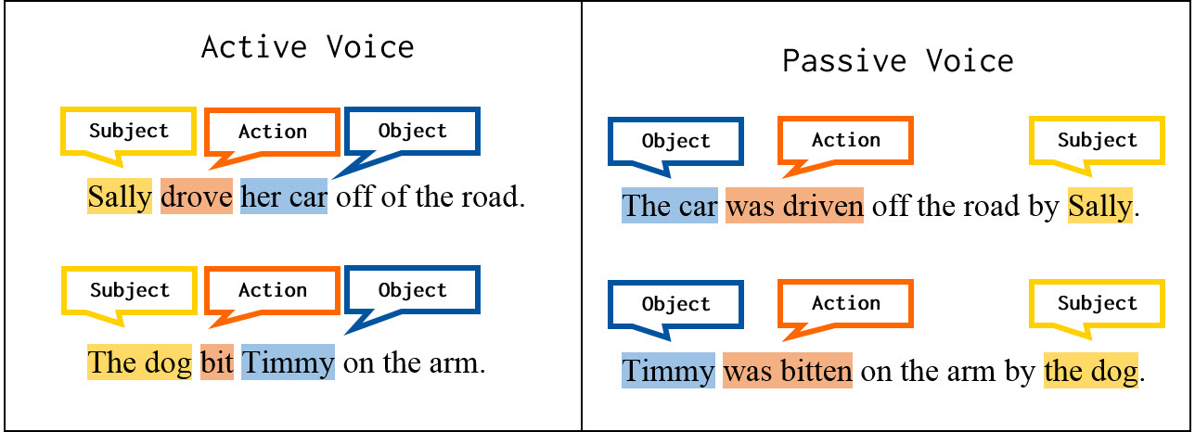

**OBJECT + BE + VERB3  (+ BY SUBJECT)**

**The form of “BE” depends on the tense / modal. Study the tables below.**

|  |  |
| --- | --- |
| Mr. Smith writes the reports. | The reports are written by Mr. Smith. |
| Mr. Smith wrote the reports. | The reports were written by Mr. Smith. |
| Mr. Smith has written the reports. | The reports have been written by Mr. Smith. |
| Mr. Smith is writing the reports. | The reports are being written by Mr. Smith. |
| Mr. Smith can / should / will / must / etc. write the reports. | The reports can / should / will / must / etc. be written by Mr. Smith. |

|  |  |
| --- | --- |
| Mr. Smith doesn’t write the reports. | The reports aren’t written by Mr. Smith. |
| Mr. Smith didn’t write the reports. | The reports weren’t written by Mr. Smith. |
| Mr. Smith hasn’t written the reports. | The reports haven’t been written by Mr. Smith. |
| Mr. Smith isn’t writing the reports. | The reports aren’t being written by Mr. Smith. |
| Mr. Smith can’t / shouldn’t / won’t / mustn’t / etc. write the reports. | The reports can’t / shouldn’t / won’t / mustn’t / etc. be written by Mr. Smith. |

|  |  |
| --- | --- |
| Does Mr. Smith write the reports? | Are the reports written by Mr. Smith? |
| Did Mr. Smith write the reports? | Were the reports written by Mr. Smith? |
| Has Mr. Smith written the reports? | Have the reports been written by Mr. Smith? |
| Is Mr. Smith writing the reports? | Are the reports being written by Mr. Smith? |
| Can / Should / Will / Must / etc. Mr. Smith write the reports? | Can / Should / Will / Must / etc. the reports be written by Mr. Smith? |

**TASK 2. Complete the tables.**

|  |  |
| --- | --- |
| Jane cleans the flat. |  |
| Jane cleaned the flat. |  |
| Jane has cleaned the flat. |  |
| Jane is cleaning the flat. |  |
| Jane can/ should / will clean the flat. |  |

|  |  |
| --- | --- |
| Jane doesn’t clean the flat. |  |
| Jane didn’t clean the flat. |  |
| Jane hasn’t cleaned the flat. |  |
| Jane isn’t cleaning the flat. |  |
| Jane can/should/will clean the flat. |  |

|  |  |
| --- | --- |
| Does Jane clean the flat? |  |
| Did Jane clean the flat? |  |
| Has Jane cleaned the flat? |  |
| Is Jane cleaning the flat? |  |
| Can/Should/Will Jane clean the flat? |  |

**(Optional Homework) Make similar tables (positive-negative-question) using these words:**

1) Tom / take / the kids / to school 2) Bob and Sue / fix / the car

**TASK 2. Rewrite the following sentences using passive voice. Omit “by phrase” if it is not necessary or if it is obvious.**

|  |  |
| --- | --- |
| 1. Someone stole my wallet. |  |
| 1. People always give me expensive gifts on my birthday. |  |
| 1. Julia’s cousin is repairing our roof now. |  |
| 1. People mustn’t destroy the rainforests. |  |
| 1. The earthquake damaged the old bridge. |  |
| 1. They will install a better heating system soon. |  |
| 1. They shouldn’t blame Tom for the company’s bankruptcy. |  |
| 1. Few people respect and trust liars. |  |

**TASK 3. Find and underline the other sentences in the passive form in the text, “The Oscars.”**

**TASK 4. Read the following sentences and decide if they are Active or Passive. Write A (active) or P (passive).**

1. ___ ____ The actress received an Oscar. ­­­­­­­­­­­­­

2. ___ ____ Many actors live in California.

3. ___ ____ Predictions are made about the winners.

4. ___ ____ They are giving an award now.

5. ___ ____ Spielberg was presented an Oscar.

6. ___ ____ The actress thanked all the people.

7. ___ ____ Spielberg presented an Oscar.

8. ___ ____ The movie was filmed in black and white.

9. ___ ____ Walt Disney won the most Oscars ever.

10. ___ ____ The actress was driven to the ceremony in a white limousine.

**At this point, let’s have a look at transitive and intransitive verbs.**

**TRANSITIVE/INTRANSITIVE VERBS**

|  |  |
| --- | --- |
| A transitive verb takes an object. The object completes the meaning of the verb. An intransitive verb does not take an object. | The new employee organized the meeting. (transitive)  Verb Object  The new employee arrived. (intransitive)  Verb |

|  |  |
| --- | --- |
| **The object after a transitive verb is often a noun or an object pronoun.** | She wears *perfume*.  My boss doesn’t like *me*. |
| **An intransitive verb does not have an object. However, it is often followed by an expression of time, place, or manner.** | The flight arrived *at 5:30 p.m*.  How many people work *at your office*?  She resigned *unexpectedly*. |
| **Some verbs can be transitive or intransitive.**  **Sometimes the meaning of the verb is the same.** | He drives a truck. (transitive)  He drives badly. (intransitive) |
| **Sometimes the meaning of the verb is different.** | She runs a company in Phoenix. (manages) (transitive)  She can run fast. (intransitive) |

|  |  |
| --- | --- |
| **Most English verbs are transitive.**  **The most common intransitive verbs in speaking and writing are *come, die, fall, go, happen, live, remain, rise, stay,* and *work*.** | He died in 1998.  Gas prices are rising. |
| **The most common verbs that can be transitive or intransitive are *begin, call, change, leave, move, open, run, start, stop,* and *study*.** | Could you move your car, please? (transitive)  We all sat very still. No one moved. (intransitive) |

**TASK 5. Read the e-mail. Label each underlined verb T (transitive) or I (intransitive) according to how it is used in the e-mail. Circle each object.**

Hi Emily,

Our new assistant started work yesterday. He seems great, except for one thing. He chews gum all the time. It distracts me and other employees. We hear it all day long. Maybe I should explain my feelings, but I don’t want to offend him. He works hard and everyone likes him. I discussed the problem with my co-worker, Kyle, but he didn’t care. He just laughed. When I arrived at work this morning, my manager and I spoke. She understood the problem. She is going to say something to the new assistant. Maybe that will help.

I hope your workday is going better than mine!

Yvette

T

**Only transitive verbs (verbs that are followed by an object) can be used in the passive because we need an object to transform an active sentence into a passive one. Intransitive verbs (go, come, live, happen, sleep, arrive, die, become, etc.) do not take an object, so they CANNOT be used in the passive form.**

e.g.

*\** People *go* to the cinema very often. (no passive form)

* The winners *come* to the stage to get their awards. (no passive form)

* Hollywood *became* the movie capital of the US. (no passive form)

|  |
| --- |
| **WHEN DO WE USE PASSIVE VOICE?** |

|  |  |
| --- | --- |
|  | **EXAMPLES** |
| 1. when the DOER of the action isn’t known or when we avoid mentioning the DOER | The movie guide **is published** in more than 20 countries.  (We don’t know who publishes it.) |
| 2. when it isn’t necessary to mention the DOER because the DOER is obvious | The movie guide **is read** in different countries.  (It is obvious that people read it.) |
| 3. when we are more interested in the action than the DOER | The movie guide **is published** to give people information about the recent movies.  (We aren’t interested in the publisher.) |

|  |
| --- |
| **WHEN DO WE USE BY-PHRASE?** |

**Compare the two sentences below:**

* *Star Wars* was directed.

* *Star Wars* was directed by George Lucas.

**The first sentence does not give any meaningful information. All films are directed. *Star Wars* is a film, and of course, it was directed, too. However, when you add the information about the director to the sentence, it makes sense. We still prefer the passive structure because the product is as important as the doer.**

**Compare the two sentences below:**

* In Germany, a lot of cars are produced every year.

* In Germany, a lot of cars are produced by people every year.

**The by-phrase is unnecessary here because the doer is obvious.**

**TASK 6. Rewrite the following sentences using passive voice. Omit “by phrase” if it is not necessary or if it is obvious.**

|  |  |
| --- | --- |
| 1. Someone stole my wallet. | **______________________________.** |
| 1. People always give me expensive gifts on my birthday. | **______________________________.** |
| 1. Julia’s cousin is repairing our roof now. | **______________________________.** |
| 1. People mustn’t destroy the rainforests. | **______________________________.** |
| 1. The earthquake damaged the old bridge. | **______________________________.** |
| 1. They will install a better heating system soon. | **______________________________.** |
| 1. They shouldn’t blame Tom for the company’s bankruptcy. | **______________________________.** |
| 1. Few people respect and trust liars. | **______________________________.** |

**TASK 7. Change the following sentences from active into passive if possible.**

1. Steven Spielberg directed *Jurassic Park.*

**______________________________________________________________________________________ .**

2. Screenwriters rewrite novels to make them into movies.

**______________________________________________________________________________________ .**

3. Did they film the movie in Hollywood?

**______________________________________________________________________________________ ?**

4. Movie stars live in California.

**______________________________________________________________________________________ .**

5. When do they hold the ceremony?

**______________________________________________________________________________________ ?**

6. Steven Spielberg is making a new movie.

**______________________________________________________________________________________ .**

7. When did this terrible event happen?

**______________________________________________________________________________________ .**

8. The public cannot buy the tickets.

**______________________________________________________________________________________ .**

**TASK 8. Fill in the blanks with the correct forms of the verbs.**

[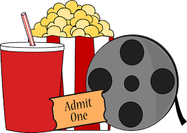](http://www.google.com/url?sa=i&source=images&cd=&cad=rja&uact=8&docid=lPhZjYlzKe5s6M&tbnid=pOM3ua8UZdpYlM:&ved=0CAgQjRw4Eg&url=http://www.mycutegraphics.com/graphics/movie/movie-night.html&ei=wWffU6ecCuKA4gS-voH4AQ&psig=AFQjCNFxHMh6I47RsXzK7N0wPnICdqKrwg&ust=1407236417238761)Last year, I (**e.g.) was given** a set of free movie tickets for my birthday. I 1)**___________________** (invite) one of my friends to go with me. We 2)**___________________** (go) to a new movie theater downtown. We saw a movie. It 3)**___________________** (direct) by Steven Spielberg. This was my first time in an American movie theater, and several things 4) **___________________** (surprise) me.

In general, people (5) **___________________** (eat) during the movie in American movie theaters. Popcorn, candy and soda 6) **___________________** (sell) in the theater lobby. People 7) **___________________** (buy) food to eat during the movie. Also, coming attractions 8) **___________________** (show) before the movie. During the coming attractions, people 9) **___________________** (talk), but when the movie 10)**___________________** (start), everybody becomes quiet.

The movie theaters in America are small and narrow. I 11) **___________________** (tell)by my American friend that the theater was big in the past, but later it 12) **___________________** (divide) into several small theaters. Today, more than five films 13) **___________________** (show) at different theaters at the same time. For example, we (14) **___________________**  (watch) a Spielberg’s movie last week, and other people (15) **___________________** (see) a different one in the next theater.

That day was full of surprises, but I enjoyed the movie very much. My friend and I 16)**___________________** (plan) to see another one very soon.

**TASK 9. Fill in the blanks with the correct forms of the verbs.**

Chocolate (1) **___________________** (make) from cocoa beans. It can (2) **___________________** (drink) or (3)**___________________** (eat). The cocoa plant (4) **___________________** (first / grow) by the Mayas, Toltecs and Aztecs more than 3,000 years ago. They (5) **___________________** (prepare) a drink from the beans and often (6) **___________________** (use) the beans as currency instead of money.

Columbus first (7) **___________________** (take) the beans to Spain in 1502, and Hernan Cortes later (8)**___________________** (introduce) the bitter cocoa-bean drink there, too. There, it (9)**___________________** (sweeten) and (10) **___________________** (flavor) with cinnamon and vanilla. It (11) **___________________** (serve) hot. This drink (12) **___________________** (remain) a Spanish secret for almost a hundred years before it (13) **___________________** (introduce) to France.

In 1657, a shop (14) **___________________** (open) in London by a Frenchman, and this shop started to sell solid chocolate. Many shops in other European capitals (15) **___________________** (follow) it. During the 1700s, the English (16) **___________________** (improve) chocolate by adding milk.

**TASK 10. Fill in the blanks with the correct forms of the verbs.**

[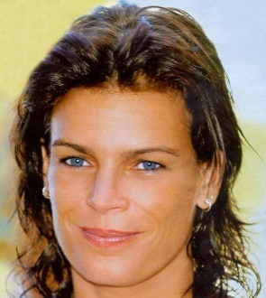](http://www.google.com.tr/url?sa=i&rct=j&q=&esrc=s&source=imgres&cd=&cad=rja&uact=8&ved=0ahUKEwjP96bR3bnQAhUBGBQKHaBWC8UQjRwIBw&url=http://anfaengerwriter.blogspot.com/2012/05/kusursuz-bir-prenses-charlotte.html&psig=AFQjCNE6GcY6SVxWaLdpBh6rbXXyv_SUtQ&ust=1479813667537554)Princess Stephanie of Monaco is the daughter of [Prince Rainier](http://www.who2.com/rainieriii.html) of Monaco and his late wife [Princess Grace](http://www.who2.com/princessgrace.html) (the former movie star Grace Kelly). Stephanie is the couple's third and last child, after [Caroline](http://www.who2.com/princesscaroline.html) and [Albert](http://www.who2.com/albertofmonaco.html). She (1)**___________________** (name) after her great-great-great-great-grandmother Stephanie de Beuharnais. Today, she (2) **___________________** (know) as the ‘rebel royal.’ This nickname (3) **___________________** (give) to the princess in the 1990s mainly as a result of her relationships. She (4) **___________________** (marry) one of her bodyguards, Daniel Ducruet and in this marriage, she had two children. Then, she divorced him and had a relationship with another bodyguard. After that, she (5) **___________________** (photograph) with Franco Knie, an elephant trainer. Then, the princess (6)**___________________** (run) away with him.

Today, Stephanie still (7) **___________________** (have) a colorful life. In addition to her relationships, Stephanie’s career in fashion and music can be called colorful, too. In 1983, she started her fashion career by working as a model for *Christian Dior*. Later, she became the face of the Swiss beauty line *La Prairie*. In 1989, the princess gave a start to her own perfume called "Stephanie," but that (8) **___________________** (last) for long.

At one point, Stephanie got bored with the fashion industry. She started to look for new ways to express herself, and she turned to music. Her first album (9) **___________________** (release) in 1986, and it was a great success. However, her next album (10) **___________________** (sell) many copies − only 3,000 copies. After she recorded a song with Michael Jackson, she ended her pop music career in 1992.

After her father’s death, Stephanie became involved in the fight against [AIDS](http://en.wikipedia.org/wiki/AIDS). These days, she (11)**___________________** (work) for [*Fight Aids Monaco*](http://en.wikipedia.org/w/index.php?title=Fight_Aids_Monaco&action=edit&redlink=1) to support people with HIV. With a group of French singers, the princess (12) **___________________**  (record) a song in order to raise funds for the foundation next week. Obviously, she never forgets about her old music days.

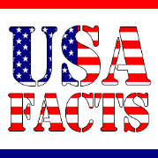**TASK 11. Fill in the blanks with the correct forms of the verbs.**

In the United States,

* … about 5,500,000 car accidents (1) **___________________** (report) to the police each year.

* … more than 37,000 people (2) **___________________** (die) in road accidents every year.

* … a person (3) **___________________** (kill) in a road accident every 11 minutes.

* … nearly one million cars (4) **___________________** (steal) every year.

* … Times Square in Manhattan (5) **___________________** (visit) by nearly 35 million people each year.

* … the average American person (6) **___________________** (drink) 600 cans of soda per year.

* … 20 million hamburgers (7) **___________________** (sell) each day.

* … 8 billion chickens (8) **___________________** (eat) each year.

* … a lot of money (over $ 50 billion) (9) **___________________** (spend) on diet plans, books, pills and meals every year.

* … an average office worker (10) **___________________** (get) 160 emails a day (including a lot of junk mail) and (11) **___________________** (check) his/her emails more than 50 times daily. On average, people (12)**___________________** (spend) nearly two hours dealing with emails a day. Email (13)**___________________** (switch off) at home, either: about sixty percent of people (14)**___________________** (check) their work emails when they are out of the office or on holiday.

* … 31% of Americans (15) **___________________** (prefer) text messages to phone calls. Texting is the most frequently used application on a smart phone, and 97% of Americans (16) **___________________** (use) it at least once a day. Over 6 billion text messages (17) **___________________** (send) each day, and 90% of all text messages (18) **___________________** (read) in less than 3 minutes.

**TASK 12. Fill in the blanks with the correct forms of the verbs.**

Online shopping is a form of electronic shopping, and it (1) **___________________** (allow) consumers to buy goods or services over the Internet. Goods and services (2)**___________________** (buy) from the online stores called e-shops or e-stores. Online shopping (3) **___________________** (become) more and more popular these days because it is so easy.

There (4) **___________________** (be) a lot of e-shops on the Internet. Shoppers can visit all these shops and shop at home using their computers. The e-shops (5) **___________________** (close), so they can shop 24 hours a day. Shoppers buy a variety of items from these stores. Books, clothing, household appliances and toys are just some examples. Then, these items (6) **___________________** (deliver) to their addresses.

As online shopping is very convenient and easy, nowadays it (7) **___________________** (use) by a lot of people. However, some people (8) **___________________** (prefer) it. They think that giving personal information on the web can be dangerous because there are hackers. In addition, some people (9)**___________________** (want) to shop online because they want to touch the product and try on the clothing. They also want to be around other people. Online shopping doesn’t allow them to do this. What (10)**___________________** (you / think) about online shopping? Do you find it enjoyable? Oh! Aren’t you an online shopper? (11) **___________________** (you / try) it in the near future?